App Inventor Tutorial
The stock market app that I created is an Android only app made using the online app developer App Inventor. App Inventor is based on a language that uses blocks. These blocks are similar to Java code but in a more user-friendly and simple way. The blocks are separated into different blocks that preform different methods. The blocks fit together like puzzle pieces and only blocks that are legal piece together to create a functioning method.
My stock market app is an intuitive app that allows any person to find the stock’s current price, how it’s trading today, its open price, today’s low, today’s high, the volume, and the time of the trade the numbers represent.
To make my stock app, I utilized a download file from Yahoo Finance that stores the stock’s data every time the ‘Get Price’ button is clicked. This is done by adding the ticker symbol that the user inputs to the end of the Yahoo Finance download URL which in turn downloads a data file. Since stocks are actively traded to update the stock’s current price the user needs to just click on the ‘Get Price’ button again to return a new data set that will be displayed.
This data is stored in an Excel spreadsheet. I then accessed the data through multiple labels that each display or store the corresponding value of the column of the downloaded Excel spreadsheet through set methods.
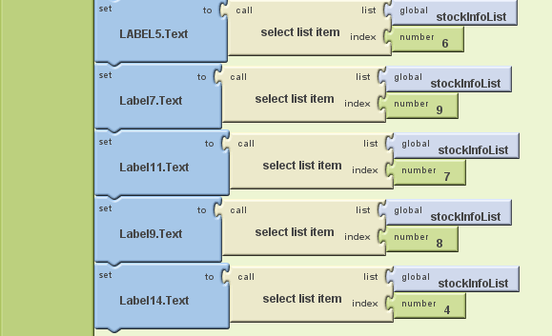
For the ‘Today’s Trade’ label I used a mathematical formula to calculate how much the stock is up or down on that day. This is done by subtracting the open price from the current trading price and multiplying that value by -1, so the label displays the correct up or down monetary value. In the blocks shown below you can see how this is done by using the multiplication and subtraction blocks.

