Scratch 2.0 Tutorial
Scratch is…
Scratch is a programming language and online community where you can create your own interactive stories, games, and animations.
To Start Scratch
  - Open Scratch @ http://scratch.mit.edu
  - Either make an account or just click “Create” to start a project
  - If you made an account, save & name your project by clicking “File” and then “Save Now”
Some Important Terms
  - Sprite – what you program
  - Stage – where your sprite “performs”
  - Script – where you put your puzzle pieces
*To move Scratch before you start running the program, click and drag Scratch to the location you want him to start
To Start & End the Program
  - Start - Click the green flag, drag Scratch back to starting point each time
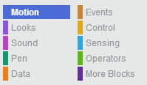
  - End – Click the red stop sign

To delete a puzzle piece
  - Drag it to the left panel
-There are different categories of puzzle pieces
  - Each color contains may puzzle pieces pertaining to that topic
  - Ex: Motion – includes puzzle pieces that make the sprite move & turn
How to make a VERY simple project
- Click File-New to start a new project
- Click “Events” in the top right corner and drag the button to Scratch’s script
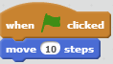
- Then click “Motion” in the top right corner and drag any of the blue puzzle pieces to the script and attach it to the orange piece that is already there
- Start the program (by clicking the green flag)
This simple program will show you how Scratch works with just a
few puzzle pieces – once you can do this, you can start to add more pieces and get creative!
How to edit a costume
  - Click the Costumes tab and click the Edit button for costume1or make a new costume
  - Use the Paintbrush, Eraser, Fill tool, Rectangle tool, Oval tool, & Line tool and the color squares to edit Scratch’s costume
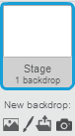
  - Click the somewhere else on the screen to save the changes that you made to the costume
How to Create a background
  - Click the Stage icon in the lower-left corner and then click any of the
four images below “New backdrop:” to edit the background
  - You can choose a background from their library, paint a background, upload an image to use, or use the camera to take a picture to use as the background
  - To save it and go back, click “Scripts”

Other Tips
To copy a block of code
- Right click on the top puzzle piece you want to copy (it copies every puzzle piece that is below it)
To copy code from one sprite to another sprite
- Drag the block of code that you want to the picture of the sprite
To change a Sprite’s size
- To make it bigger
- To make it smaller
- On the gray bar at the top of the screen, click the button (if you want it bigger or smaller) and then click on the sprite that you want to change
- Click on it as many times as you want in a row and then move your mouse off the sprite
To create a new sprite
- Click on one of the four images next to “New sprite” to either choose one from their options, draw one, upload an image to use, or take a picture to use
To delete a sprite
- Right click on the sprite you want to delete and then click “delete” from the options
http://scratch.mit.edu/scratchr2/static/__v-2013-05-22-19-09-4 g532f74b__//pdfs/help/Scratch2Cards_Jan2013.pdf **Click on the link above to go to a website with helpful tips
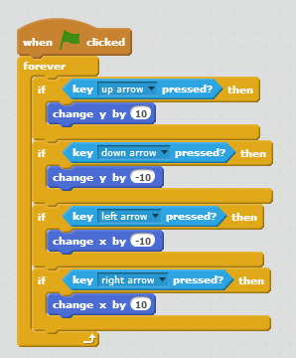
How to Make a Maze
  - Create a new project and save it with the name “Maze”
  - Add a new sprite to the project & choose to paint it
  - Draw a few lines of any color to create a maze and name it “Maze”
  - Use the Shrink sprite button at the top of the window to resize the
Scratch sprite so that he fits in the lines of the maze
  - Drag Scratch to the desired beginning position of the maze
  - Add code like this to make the arrow keys work
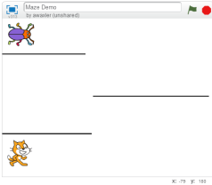
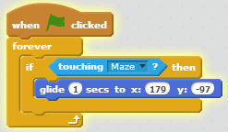
  - To make Scratch go back to start if he touches the lines of the maze, add code like this, but make the x and y numbers to wherever you want Scratch to start the maze
** If you want to make your maze more complex,
you can add another sprite and put it at the end of
the maze for Scratch to reach
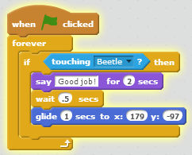
- To do this, add code like this
- Where it says “Beetle” make sure it says the name of the new sprit
- You can also change what Scratch says after it touches the new sprite
(where on my code it says “Good Job!”)
- Lastly, make sure you make your x and y numbers wherever you
want Scratch to start the maze (to find these numbers, drag Scratch to
where you want him to start the maze and record use those x and y numbers that are located in 2 places)
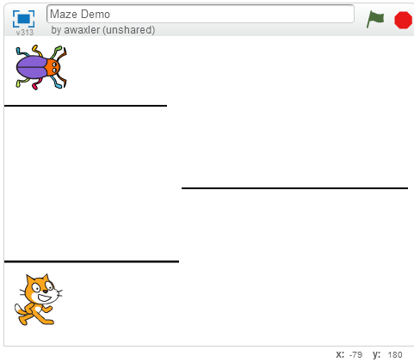
1. 2.

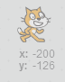
To view my Scratch Demo Programs… Go to http://scratch.mit.edu/search/projects/?q=awaxler&date=anytime&sort_by=datetime_shared

