Scratch Name:
Scratch Debug’em Worksheet #1 Period:

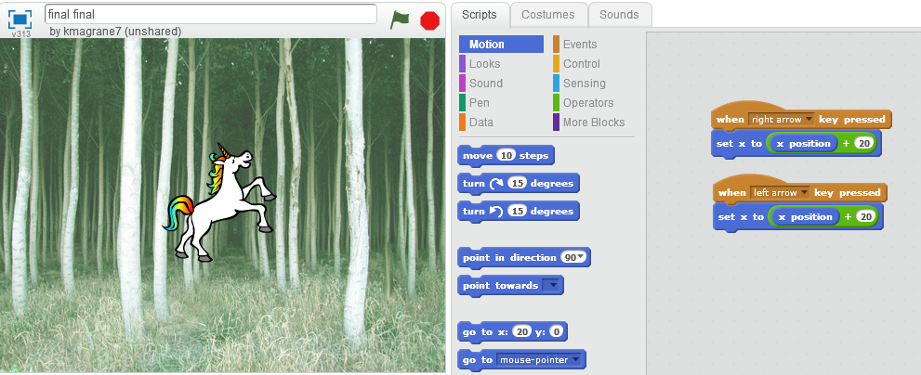
- The right arrow works correctly, why doesn’t the left arrow key work?

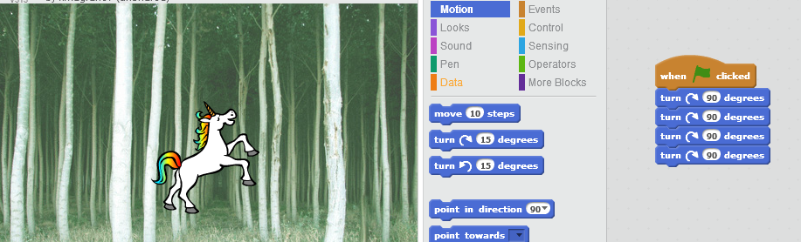
- Why won’t the cat spin in a circle?

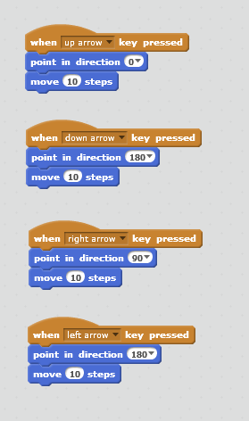
- Why won’t the cat move around the screen? (Hint: only one is wrong)

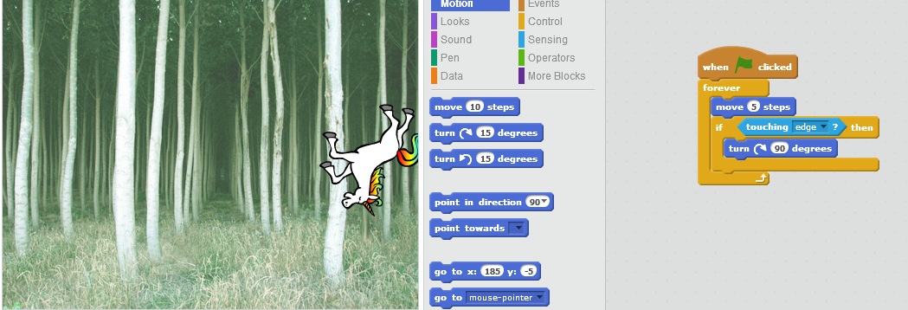
- I want the cat to walk across the screen and turn upside down but instead it keeps spinning in a circle, why?

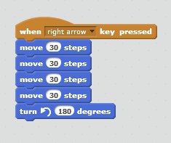
- I want the unicorn to move forward then turn upside down and then flip up back upright move backwards but he won’t, why?

