Understanding Snap!
The programming language Snap! is an easy to learn drag and drop language. Snap! is browser based so you can use it wherever you have an internet connection. This makes Snap! convenient for you to access. With the ease of access and the simplicity of the language, Snap! is a great language for young people who want to program.
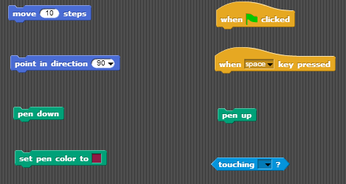
- Snap! uses a system I which blocks containing code are snapped together to make code segments. The blocks have these little notches that attach to each other.

- The gold blocks are command blocks. These blocks start your code segment.

- The dark blue blocks are motion blocks that move the small triangle shaped sprite in the grid window. These move the sprite by pixel, so 10 pixels would be a small amount of motion, while 100 pixels would be a large amount of movement.

- The green blocks are for making the sprite draw a line behind it while it moves, only if the pen down block is attached to the code segment.

- The light blue blocks are for sensing. These blocks would allow you to make it so if the sprite touches the pen trails of another sprite, it could be forced to move away from it or not be allowed to cross it.

- This would be an example of a blank grid, which you would see if you accessed the Snap! website.
- The demo I created for this tutorial is a small maze game using the motion, command, and pen blocks. I used three sprites, two of which draw the maze walls and the other is your character.
- Below is some of the code segment I used to create the walls of the maze.
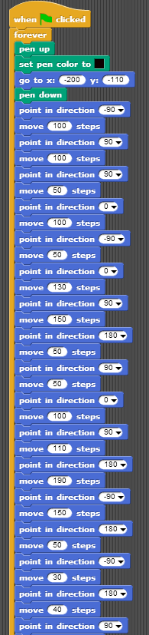

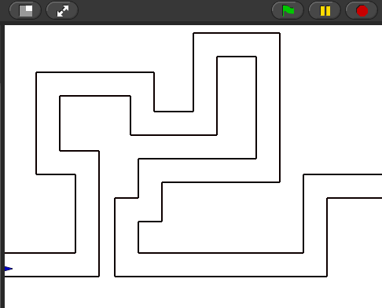

- This is the grid showing the maze and the blue sprite that you play as.

