App Inventor and Game Tutorial By: Nathan Hartman
The Exp Clicker app that I have created is an Android only app made using the online app developer App Inventor. App Inventor uses blocks instead of hardcore coding, that are similar to Java code but in a more user-friendly and simple way. These blocks are sorted into categories for different methods and different objects. The blocks snap together like puzzle pieces and will only join another block if it fits in its cut out, again like a puzzle piece.
My Exp Clicker app is a game that has multiple buttons below a set of labels that display your stats. These stats include: level, exp, and money. The object of the game is to reach the maximum level. You gain levels by gaining enough exp. Exp is gained by clicked on the Add Exp button. Greater amounts of exp can be obtained with money, which is obtained every level up.
The first thing I did was create four global variables. One for your level, exp gained, exp needed, and money. These variables are displayed in the stats labels I talked about earlier.
To make my game app, I used a series of 9 buttons, along with a LOT of If Statements. The buttons on the left allow you to gain exp, while the buttons on the right unlock the buttons on the left, for a certain price. You can tell you have unlocked a button because the right button will disappear and the left one will change it’s color. A notification will also pop up.
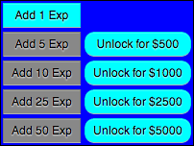
When your exp gained is equal to the exp needed, you gain a level. When you gain a level a few things occur: a notification appears, your level is increased by one, your gained exp is reset to zero, your exp needed is increased, your money is increased, and a few of the labels are reset.

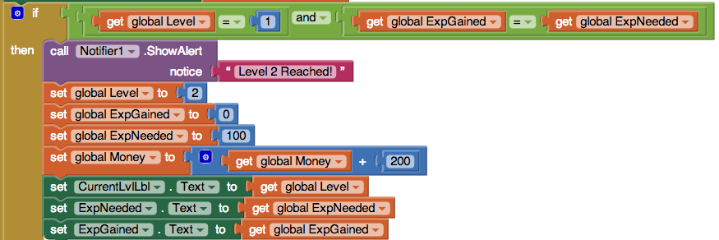

From levels one through ten, the level up blocks are the exact same set of blocks, with some of the numbers changed. If you exede level ten, then the labels will display something a little different (shown below).

When you click on an unlock button, if you haven’t already unlocked it and if you have enough money, then the gain exp button is correctly colored, the unlock button disappears, unlocked is set to true (so you can tell if its been purchased or not), the amount of money the button is worth is subtracted from your total money, and finally, an alert is shown saying that the purchase was successful.
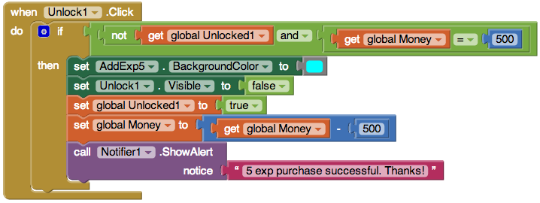

My app, Exp Clicker, has the possibility to be expanded greatly, due to the recurring blocks in each if statement. App Inventor allows you to copy a block, or set of blocks, and paste them somewhere else. You can then change certain aspects about each block. Other than that, it’s really a simple game to create. Have fun clicking!

